SE Assignment 4

Name: Himani Verma

Admission no: U19CS075

Based on Spin/ Promela

1. Write a program to create a process that prints “Hello World”. Use run in init process to instantiate it and _pid to print the ids of all create processes.

Source Code:

active proctype Hello(){

    printf("Hello world\n")

}

init{

    int lastpid;

    printf("init process, my pid is: %d\n",_pid);

    lastpid = run Hello();

    printf("last pid was: %d\n", lastpid);

}

Output:

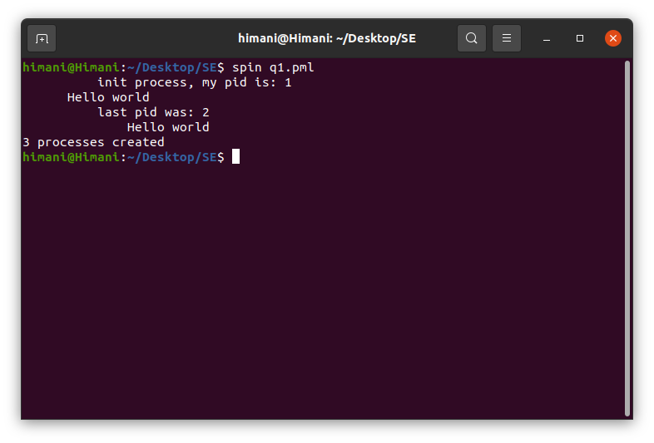

2. Model Euclid’s algorithm for Greatest Common Divisor.

Source Code:

proctype gcd(int a; int b){

    if

        :: (b == 0) -> printf("GCD of 5 & 10 is %d\n", a)

        :: (b != 0) -> run gcd(b, a%b)

    fi

}

init{

    run gcd(5,10);

}

Output:

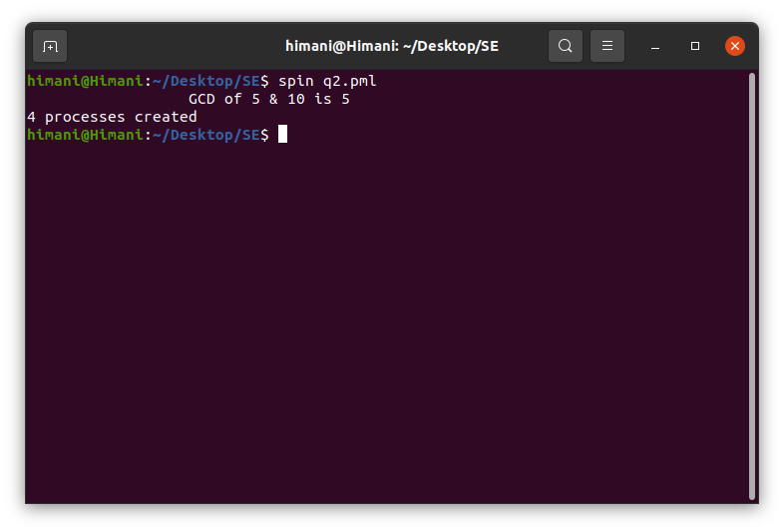

3. Create a process factorial(n, c) that recursively computes the factorial of a given non-negative integer “n”.

Source Code:

int res =1;

proctype fac(int n){

    if

        :: (n == 1) -> printf(" Factorial of 5 is %d\n",res)

        :: (n >= 2) -> res = res *n; run fac(n-1)

    fi

}

init{

    run fac(5);

}

Output:

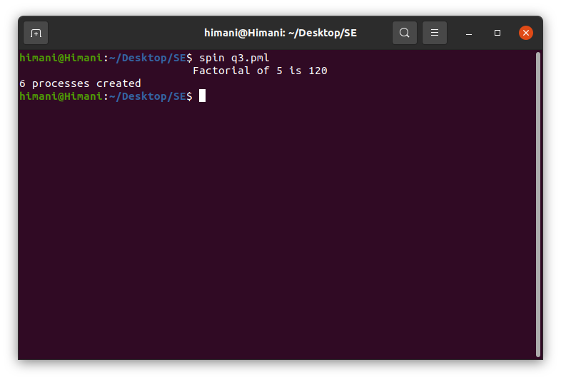

4. Create a Promela model for producer-consumer problem with buffer size 5.

Source Code:

mtype = { P, C }; /* define 2 symbolic values: P and C */

mtype turn = P; /* global variable */

active proctype producer(){

     do /* loop */

        :: (turn == P) -> /* guard of the case */

            printf("Produce\n");

            turn = C

    od

}

active proctype consumer(){

    do

        :: (turn == C) ->

            printf("Consume\n");

            turn = P

    od

}

Output:

